**Practical:-3 Deploy your web app with the help of FileZilla.**

**Step1:-** Firstly go to create a resource

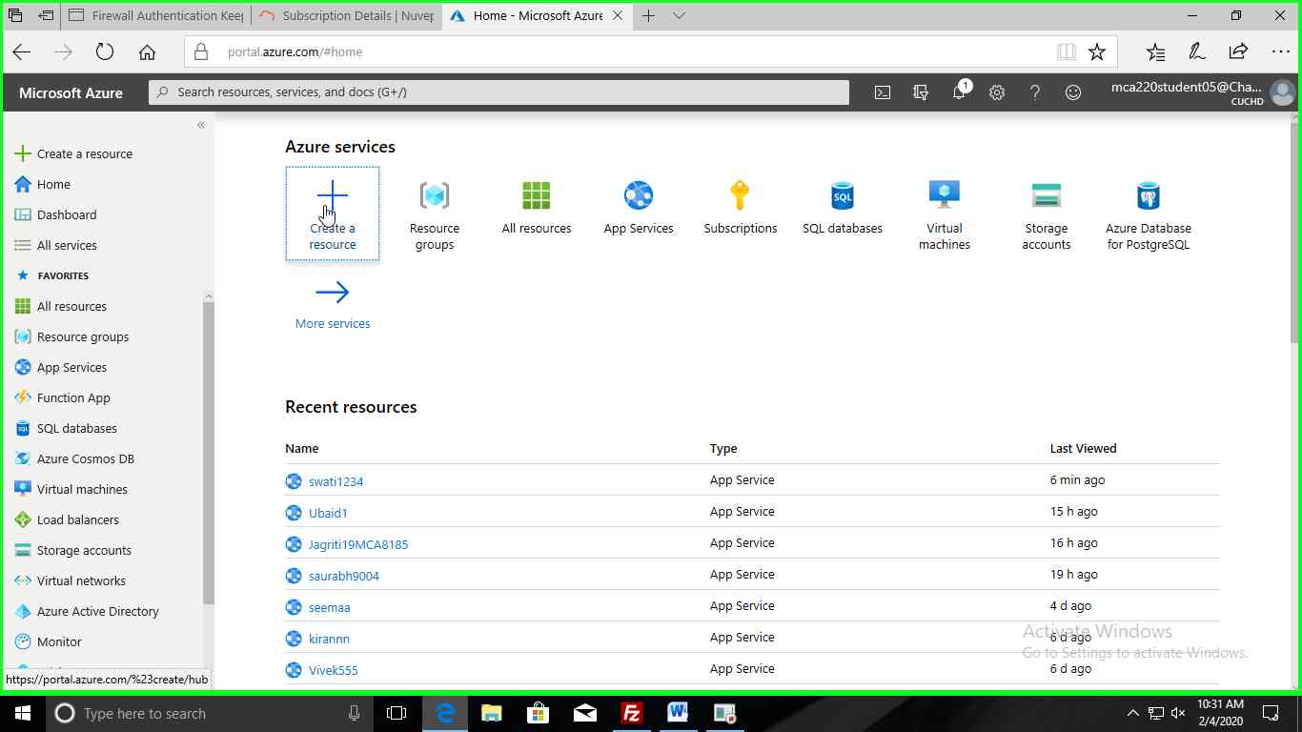

**Step2:-** Then click on **web App**

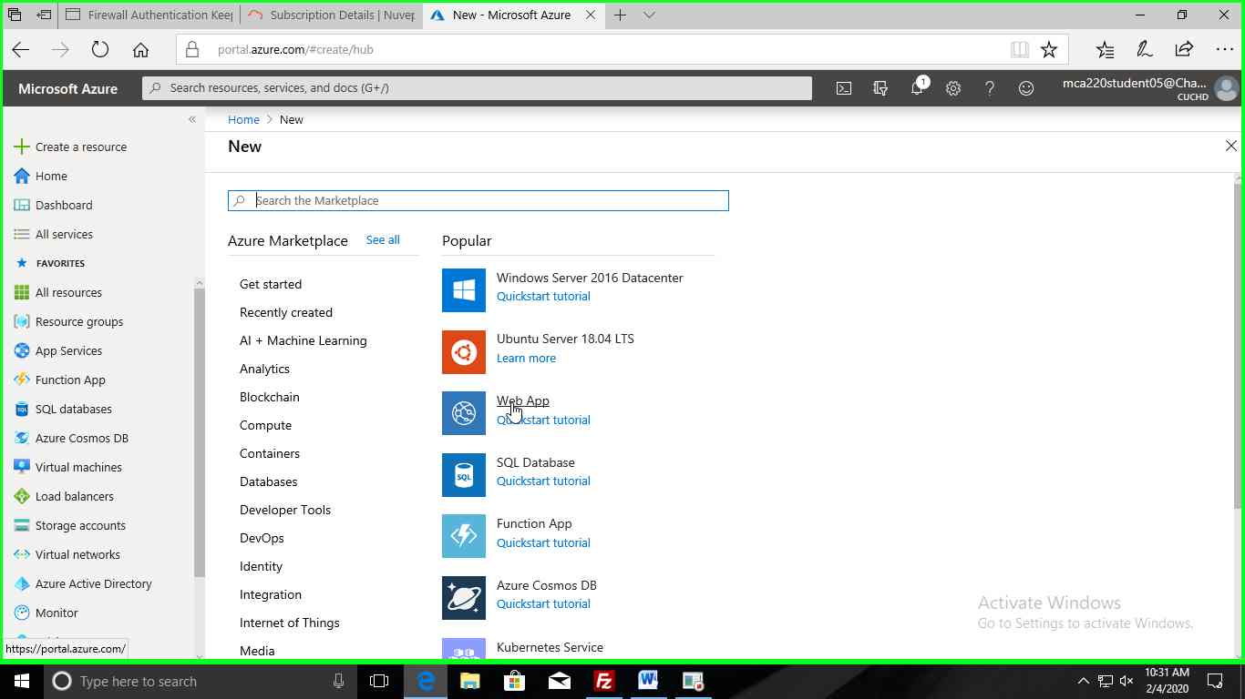

**Step3:-** Now fill the required fields.

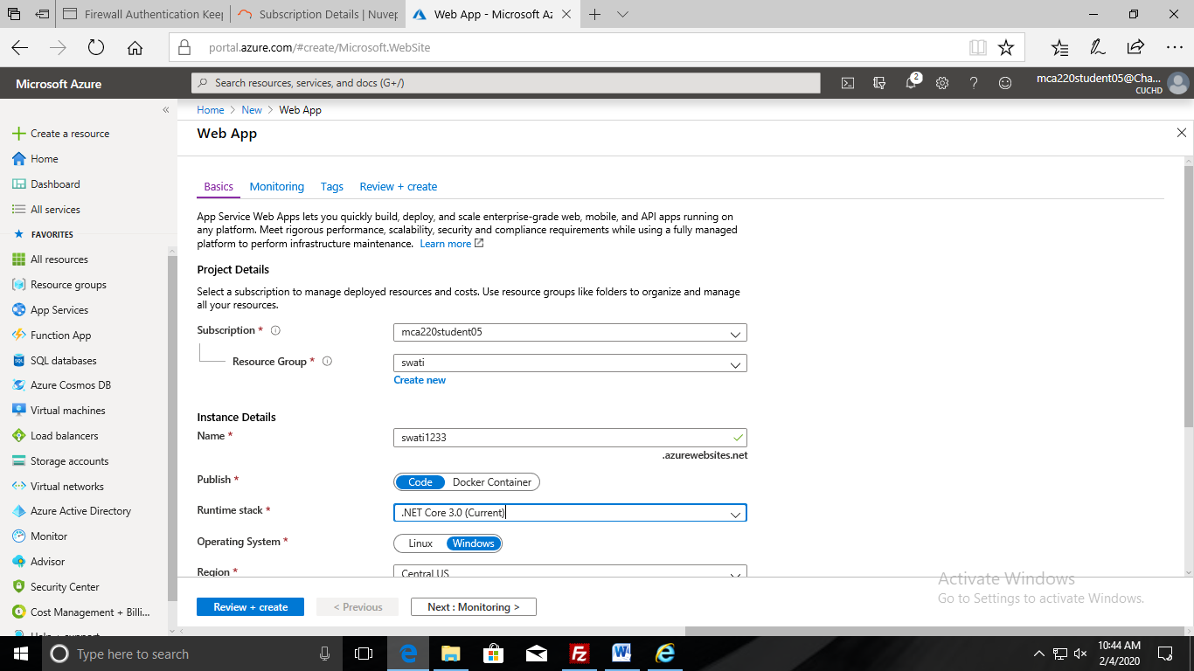

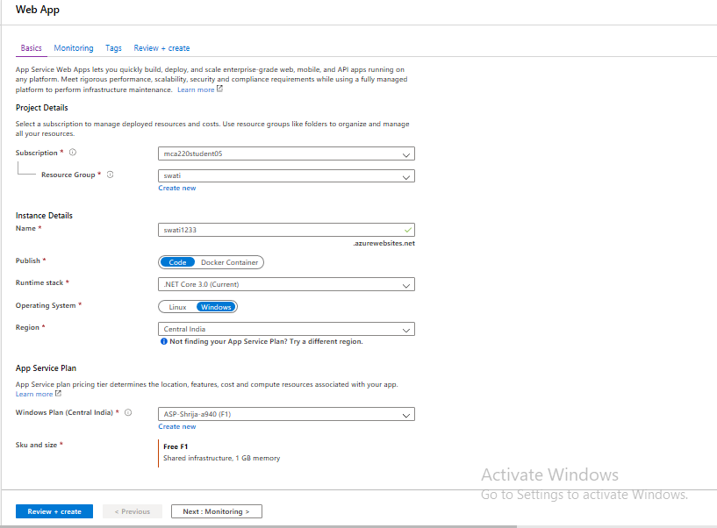

**Step4:-** After that click on “**Next: Monitoring>”** button.

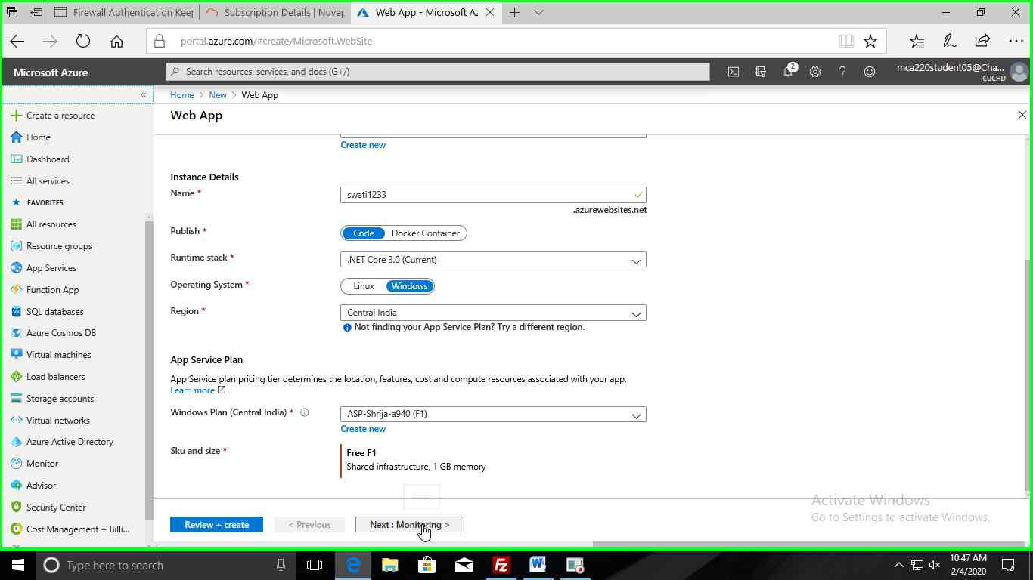

**Step5:-** Then click on “**Next: Tags>”.**

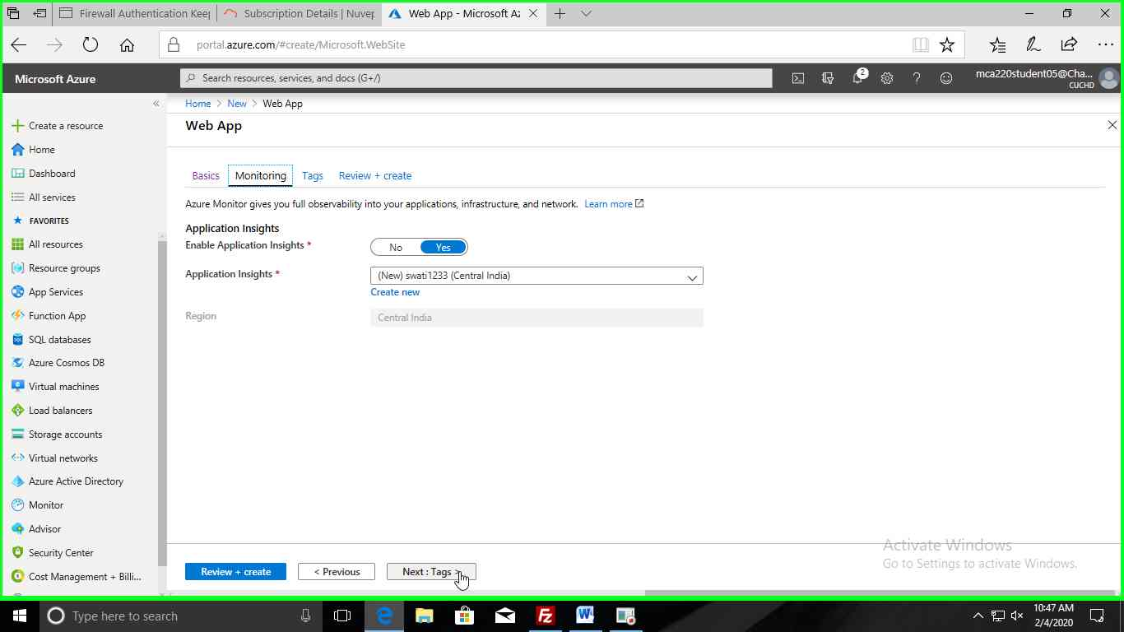

**Step6:-** Click on “**Next:Review+create>”.**

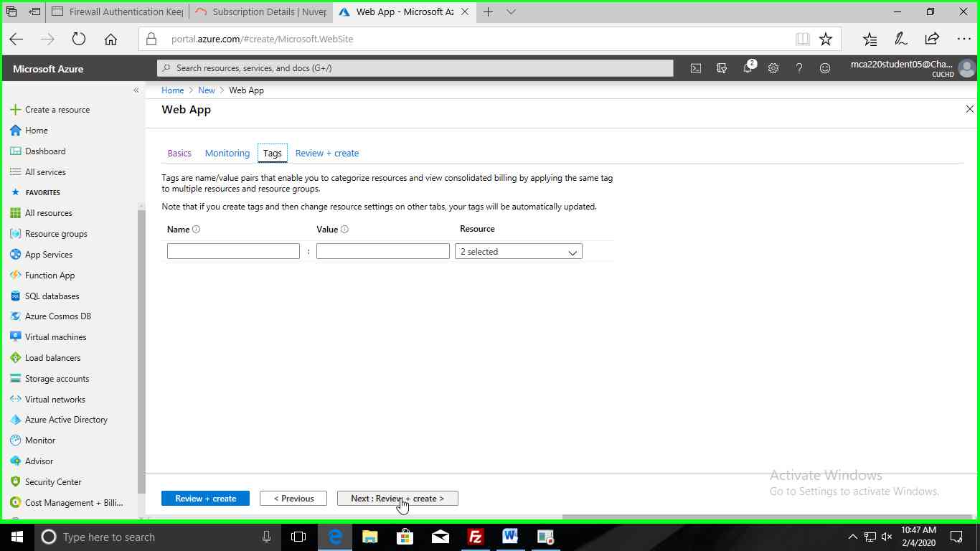

**Step7:-** Then click on “**Create**” button under “**Review +create**” tab.

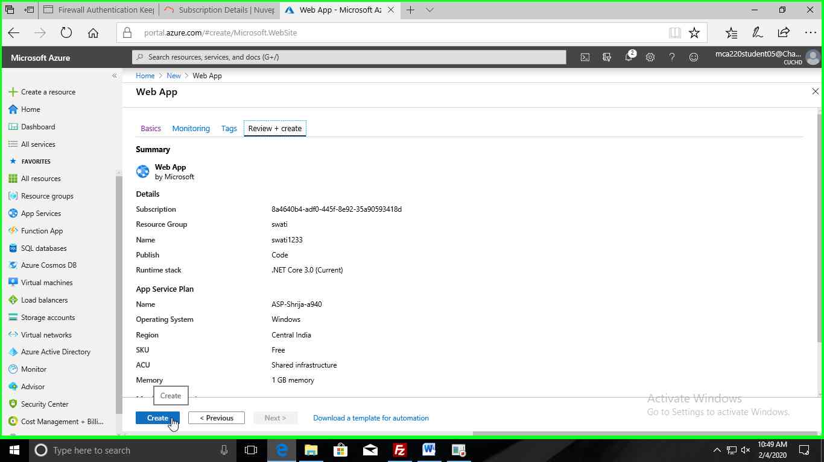

**Step8:-** Now the deployment start processing.

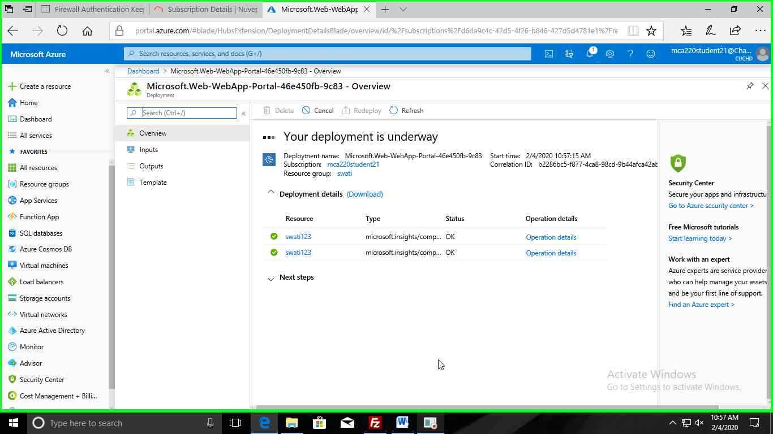

**Step9:-** After your deployment complete then click on “**Go to resource**” button.

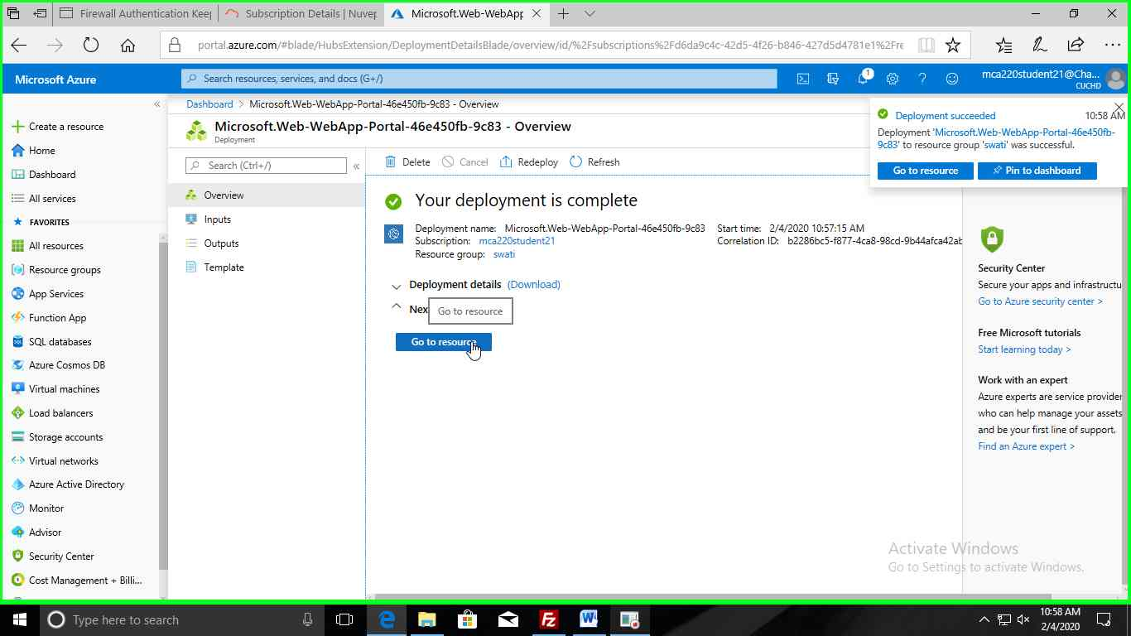

**Step10:-** Click on “**Deployment Center**” under deployment tab.

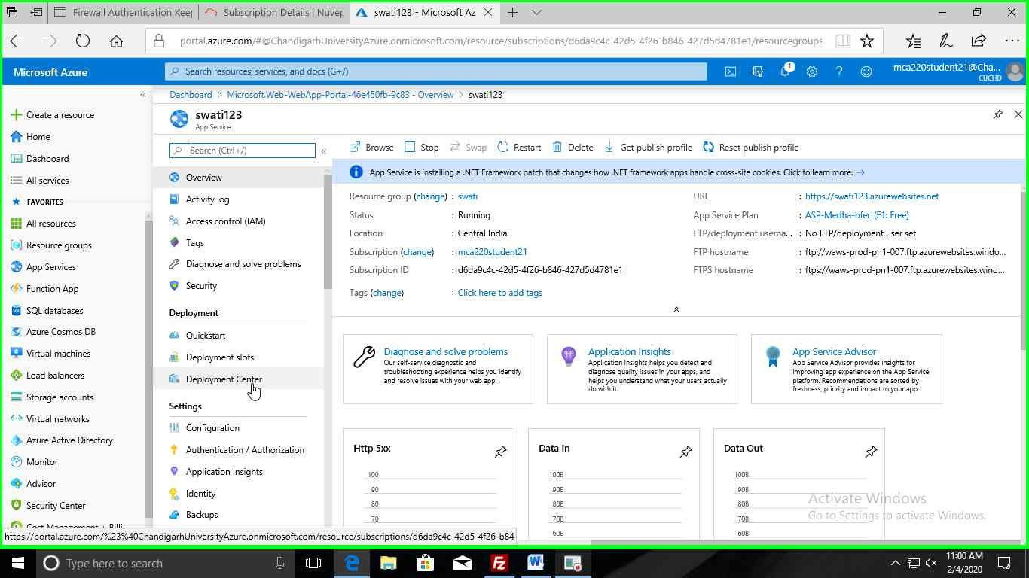

**Step11:-** Under Deployment Center click on “**FTP**” Option.

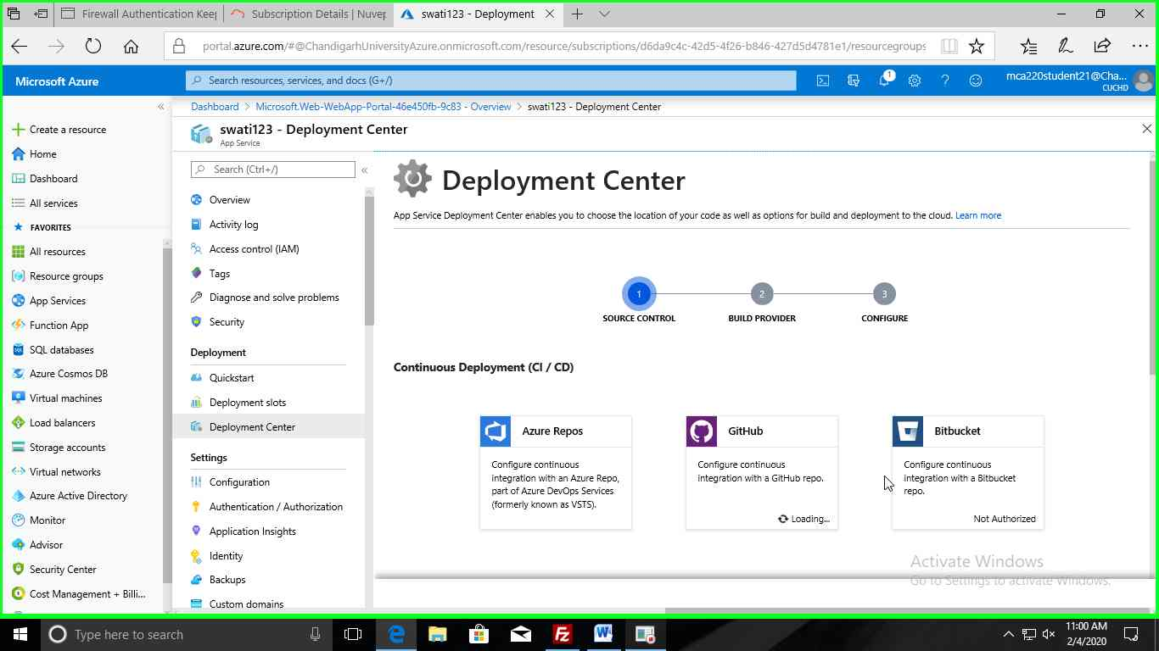

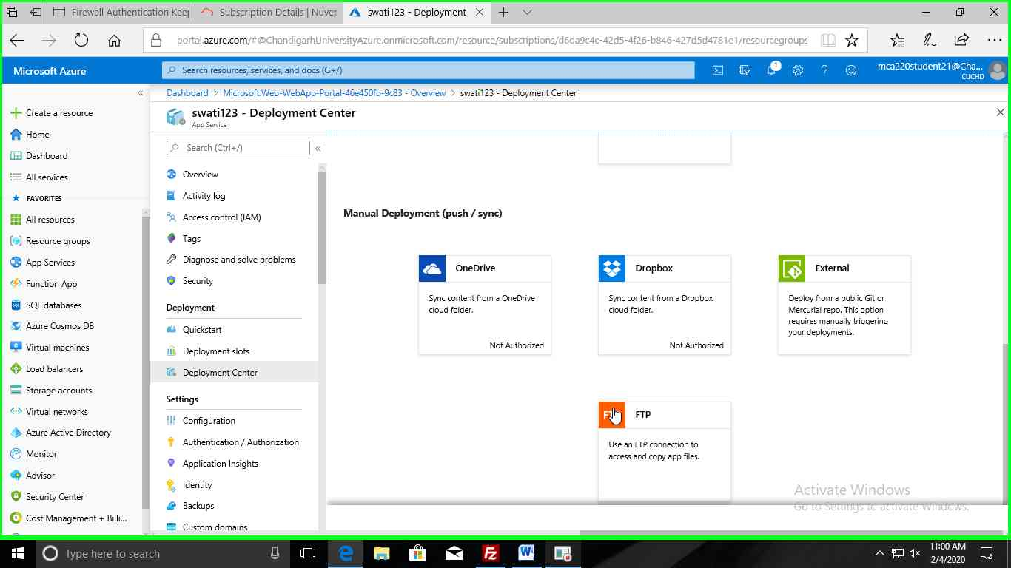

**Step12:-** Now Click on **dashboard**.

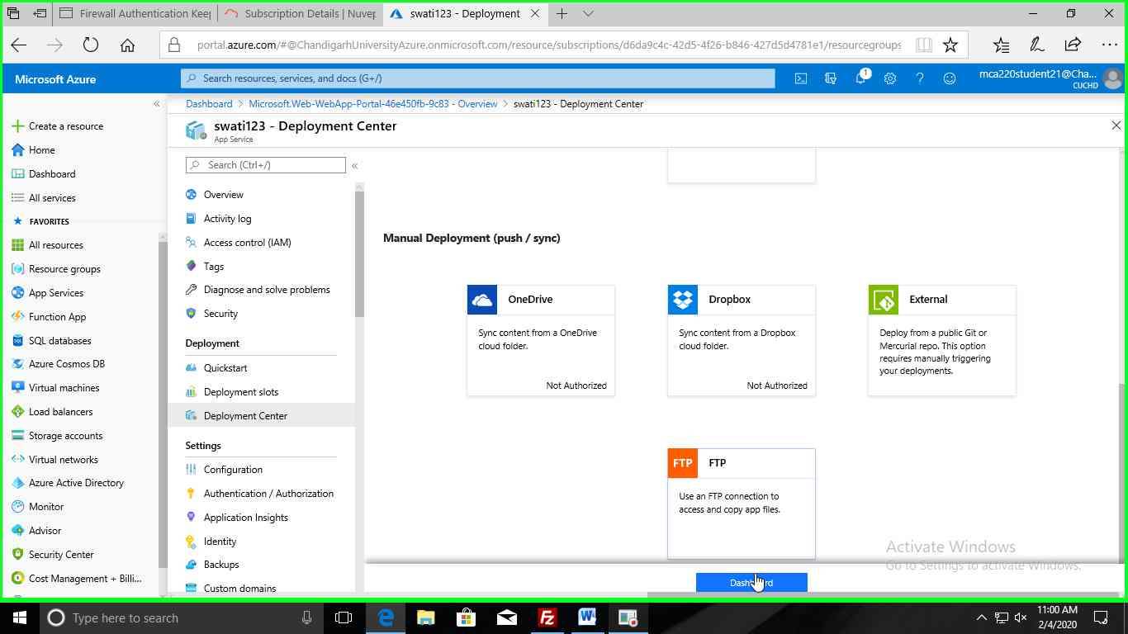

Now app credentials will open.

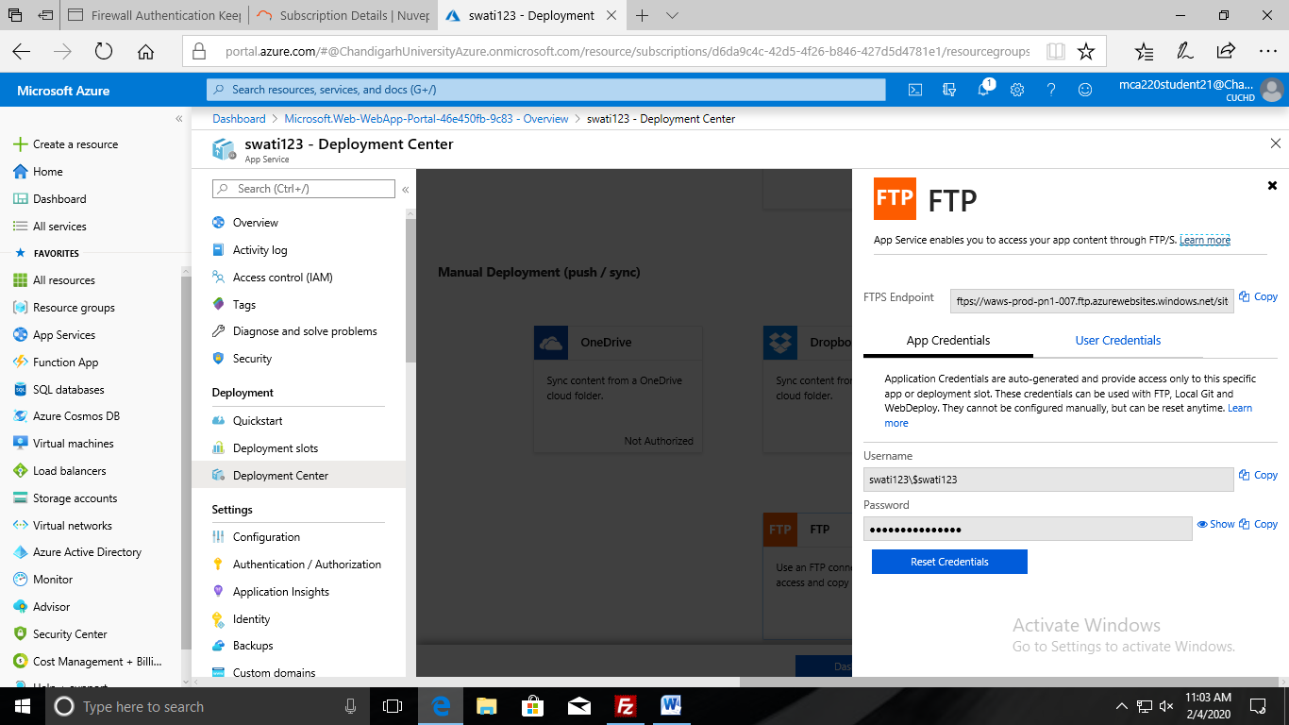

**Step13:-** Now open the FileZilla app.

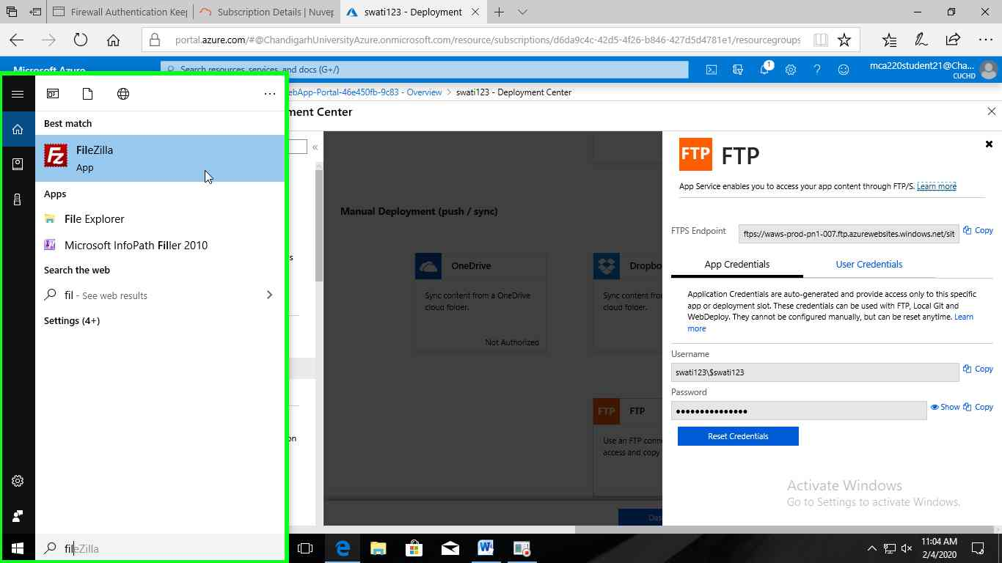

FileZilla is now open.

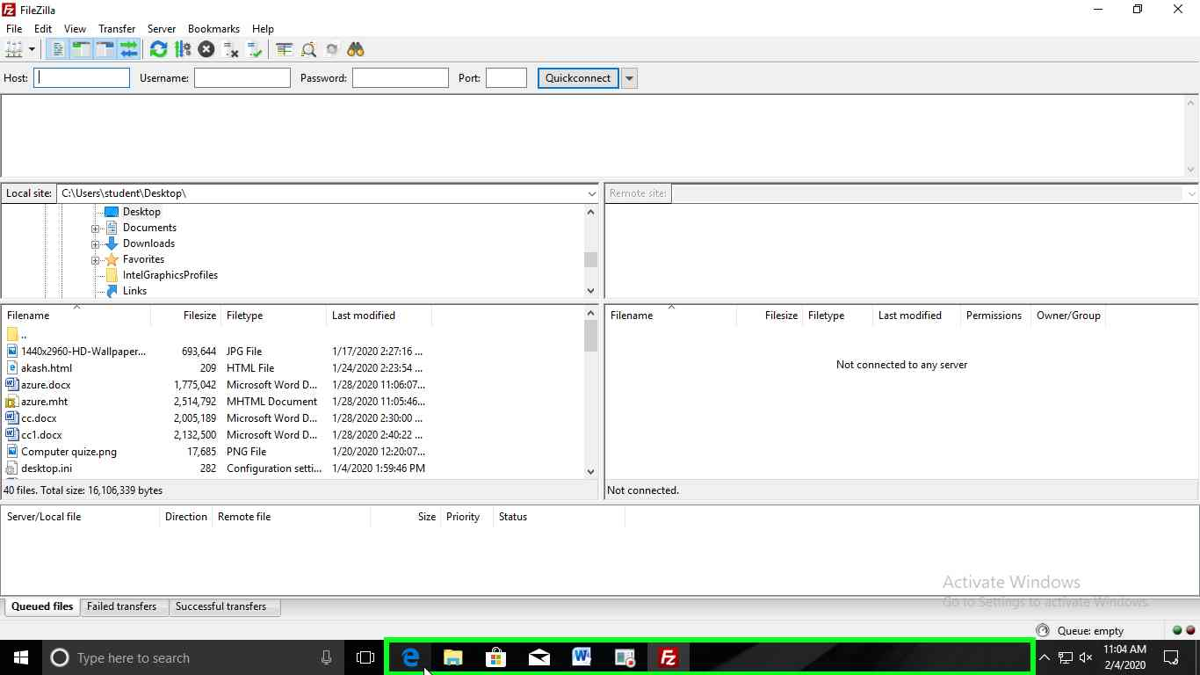

Now copy paste the app credential under the app content through FTP/s into FileZilla i.e copy your FTPS Endpoint into host option in FileZilla , username and password also.

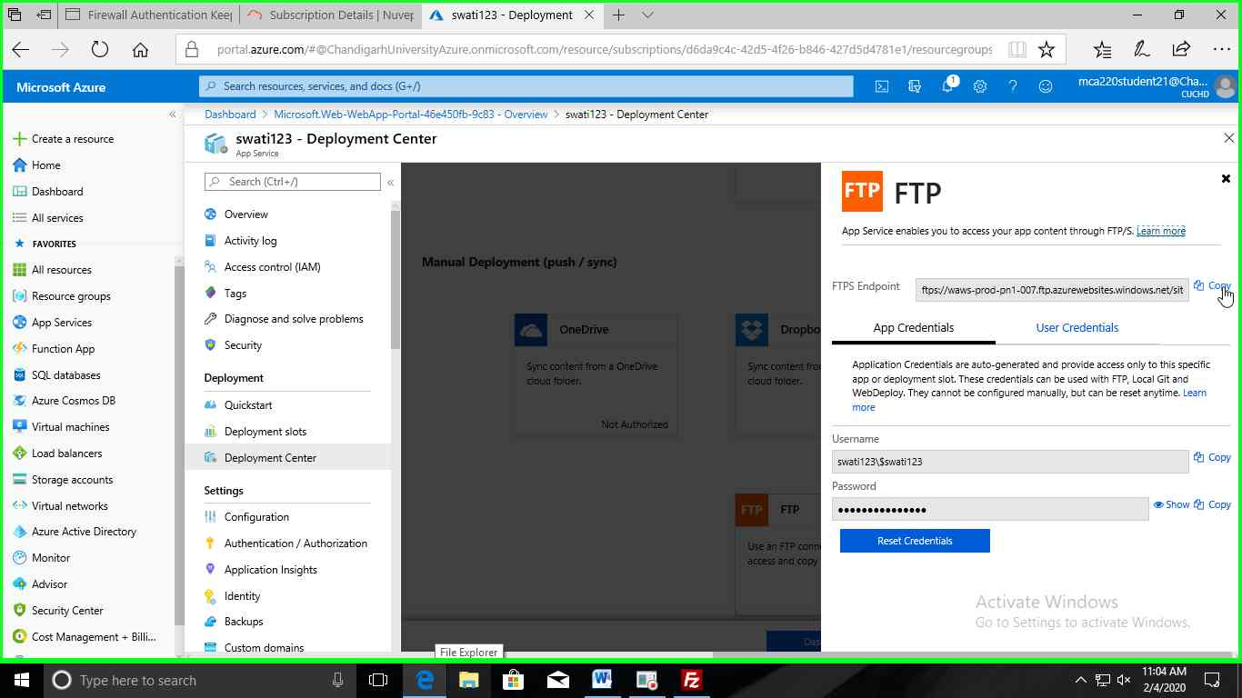

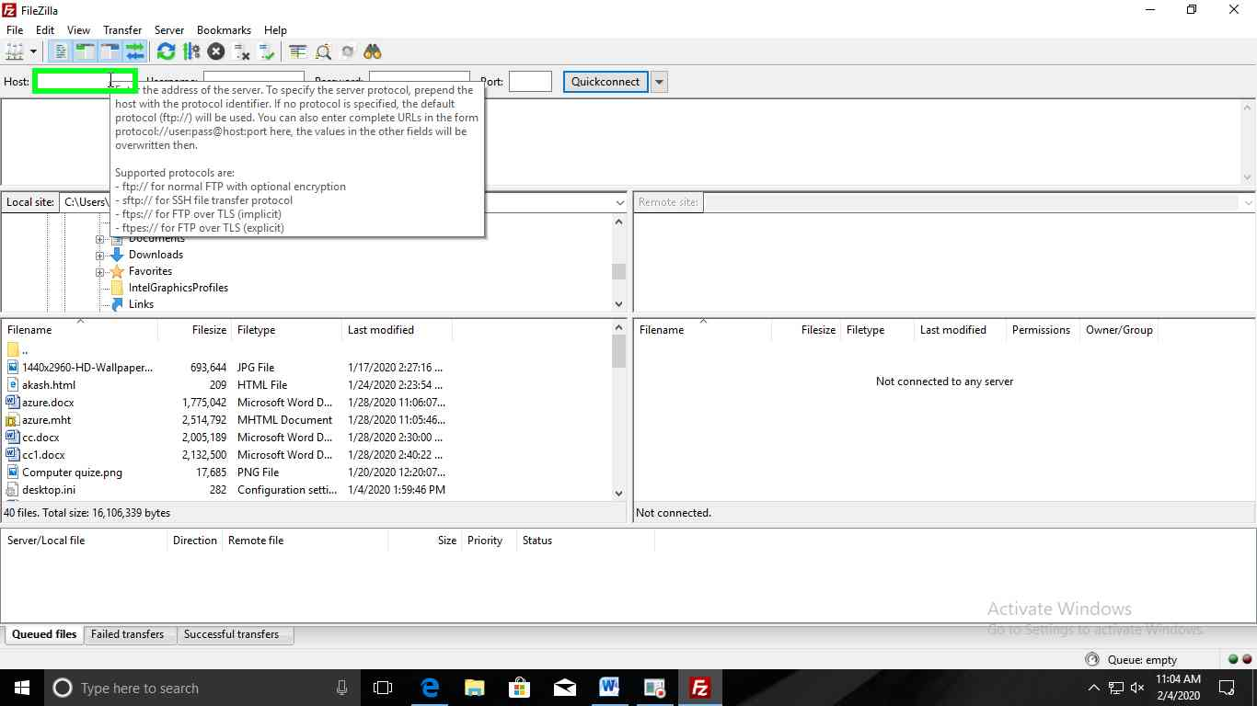

**Step14:-**After filling the credentials, Click on "**Quickconnect** " button in "**FileZilla**".

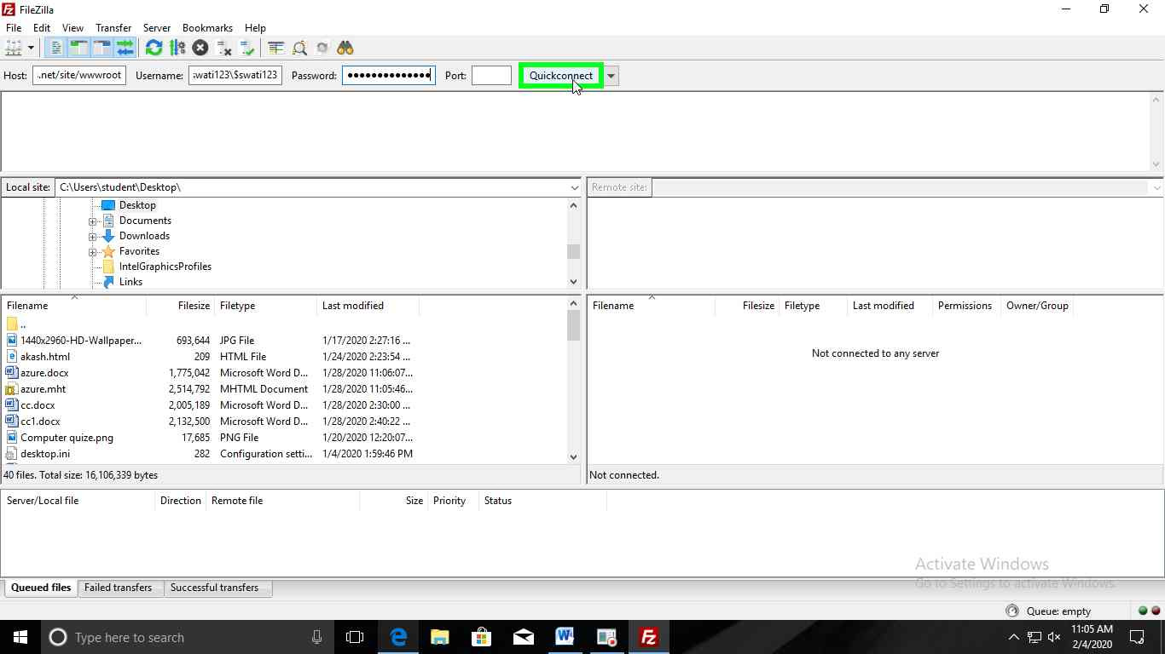

**Step15:-** Now Select your index file that you are created.

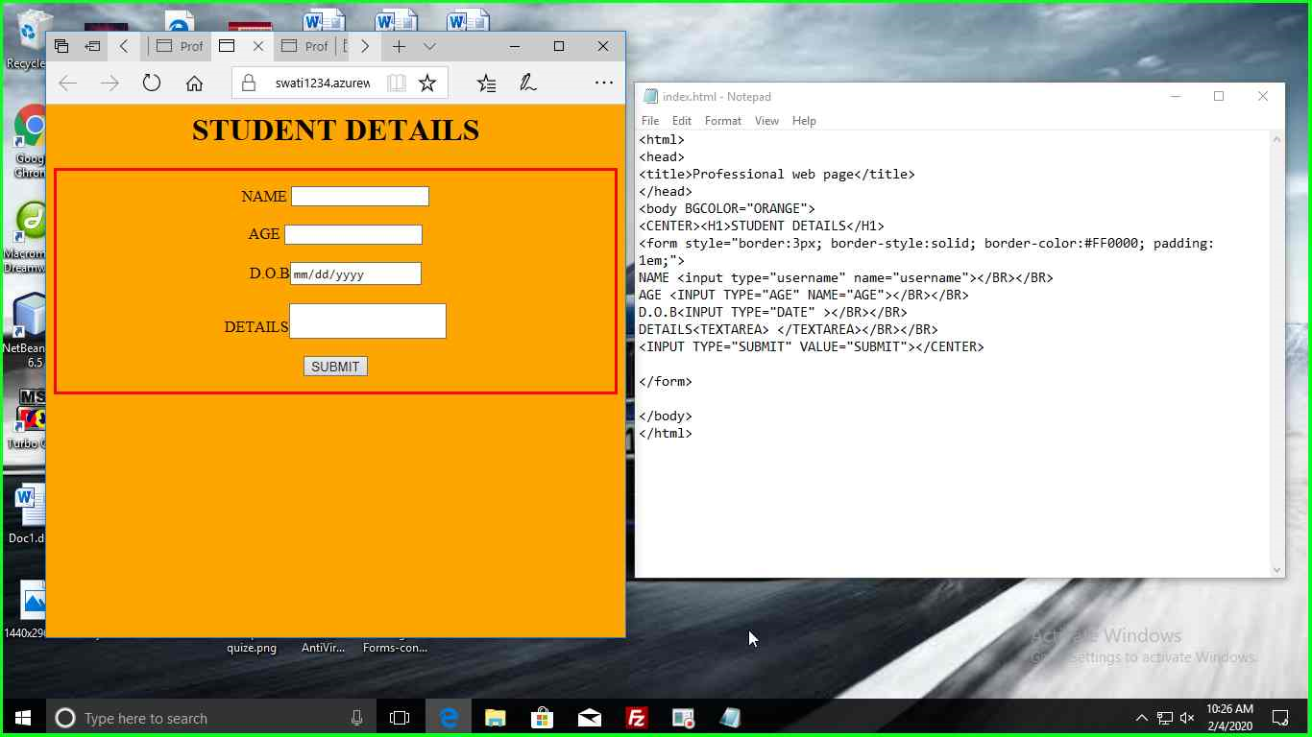

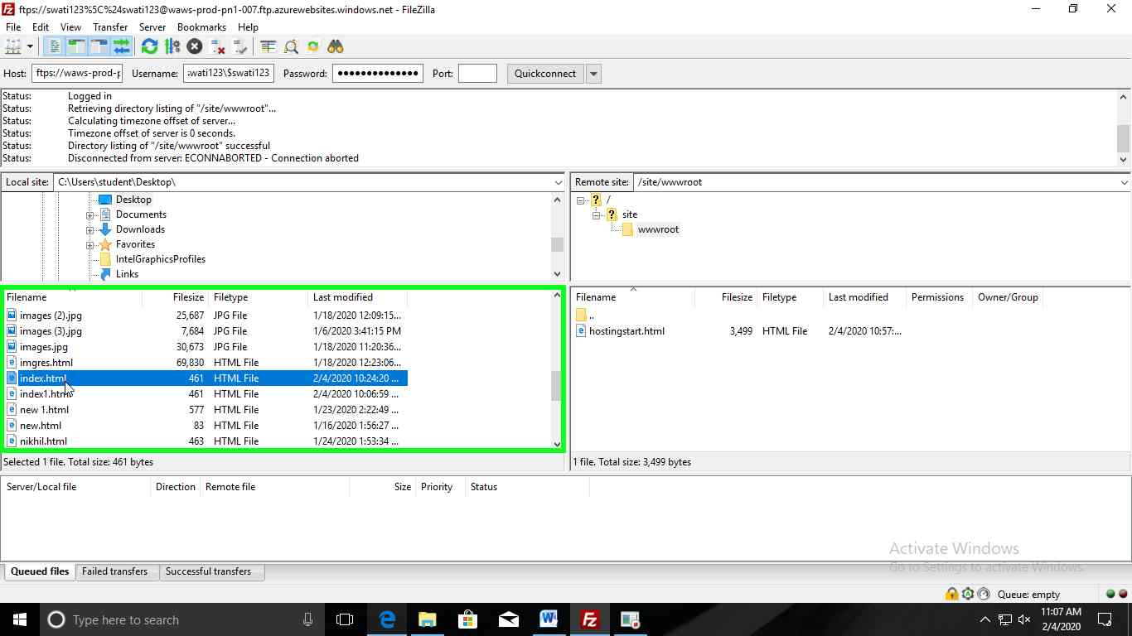

Your index file is now uploaded in wwwroot site.

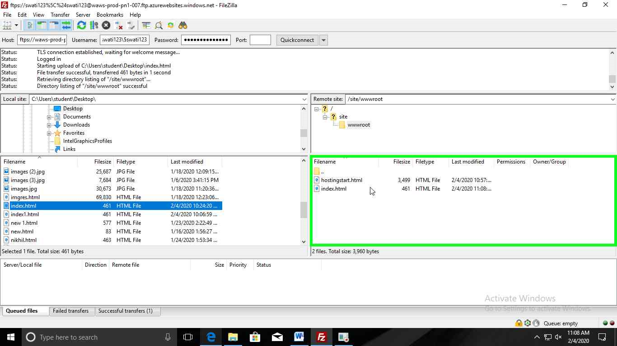

**Step16:-** Now click on “**Microsoft azure**”.

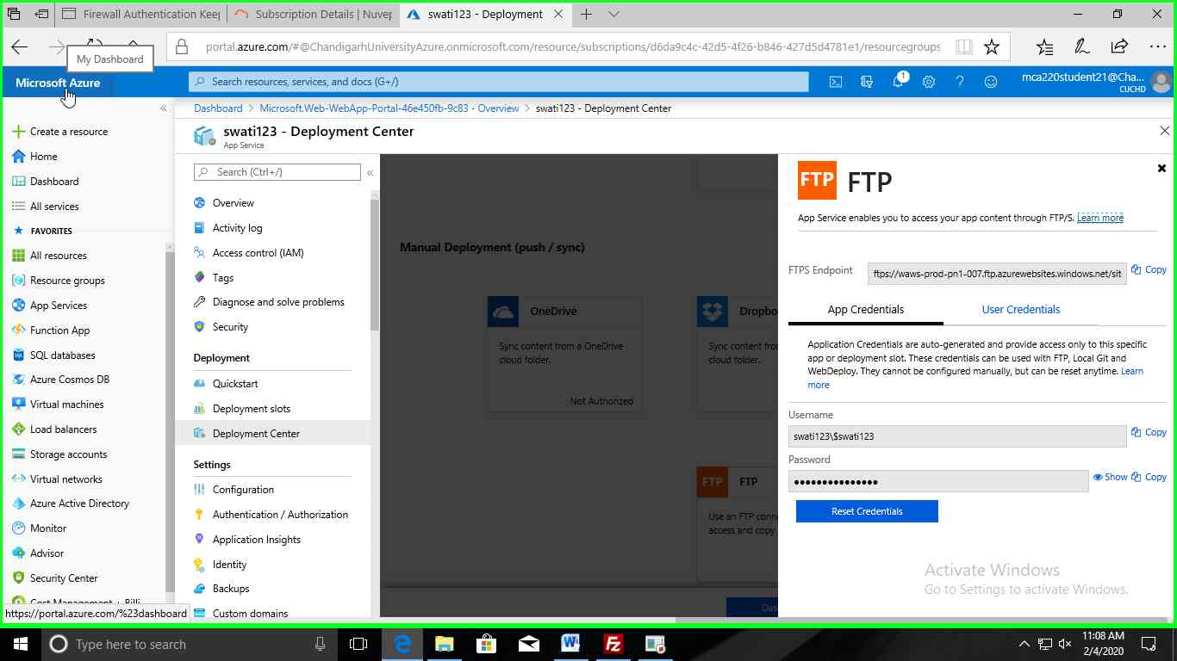

**Step17:-** Now click on your app service.

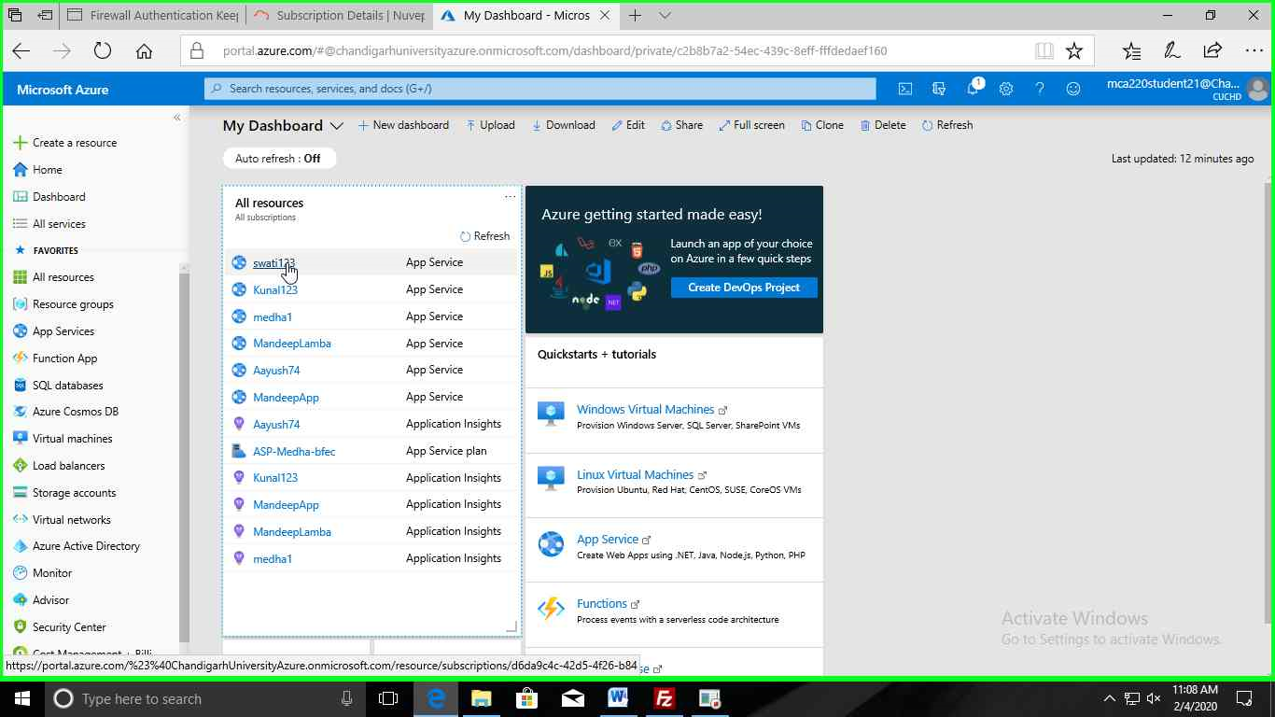

**Step18:-** Now click on **URL** link under App service.

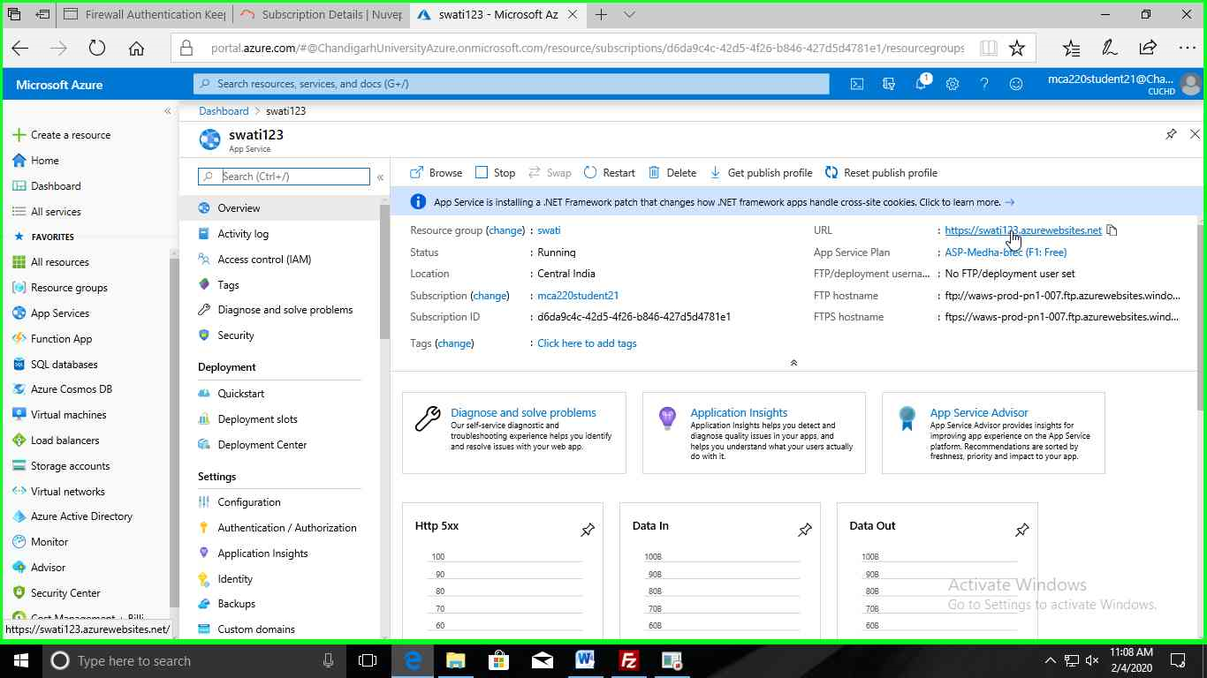

Your web app is deployed by FileZilla.

